**Moulik Tammana**

**Wi-Fi Training Program Module – 1**

**Q1. In which OSI layer the Wi-Fi standard/protocol fits.**

**Wi-Fi operates primarily at the Data Link Layer and Physical Layer (layer 1 and 2) of the OSI model.**

**Physical Layer (Wi-Fi) is responsible for the following:**

* **The Physical Layer manages the transmission of data over the air using radio waves, handling modulation and demodulation to convert digital signals into electromagnetic waves and vice versa.**
* **It defines frequency bands (2.4 GHz, 5 GHz) and specifies modulation techniques such as DSSS, FHSS, and OFDM to optimize data transfer, minimize interference, and improve efficiency in modern Wi-Fi standards like IEEE 802.11a/b/g.**
* **The Physical Layer also determines antenna configurations, transmission power levels, and channel bandwidths (20 MHz, 40 MHz, 80 MHz, 160 MHz). It employs MIMO technology for better performance and beamforming to enhance signal quality.**
* **Ultimately, this layer is responsible for converting digital data into Wi-Fi signals, enabling seamless wireless communication across networks.**

**Wi-Fi in Data Link layer is responsible for the following:**

* **Wi-Fi operates at the Data Link Layer (Layer 2) of the OSI model, managing Media Access Control (MAC) and ensuring reliable data transfer. It handles framing, addressing, and error detection before passing data to the Physical Layer.**
* **To prevent collisions, Wi-Fi uses CSMA/CA (Carrier Sense Multiple Access with Collision Avoidance), allowing multiple devices to communicate efficiently in a shared wireless medium.**
* **Wi-Fi structures data into frames, assigns MAC addresses, and employs Cyclic Redundancy Check (CRC) for error detection and integrity.**
* **The Data Link Layer also ensures security through WPA2, WPA3, and 802.1X, providing encryption and authentication to protect against unauthorized access and eavesdropping.**

**Q2. Can you share the Wi-Fi devices that you are using day to day life, share that device's wireless capability/properties after connecting to network. Match your device to corresponding Wi-Fi Generations based on properties.**

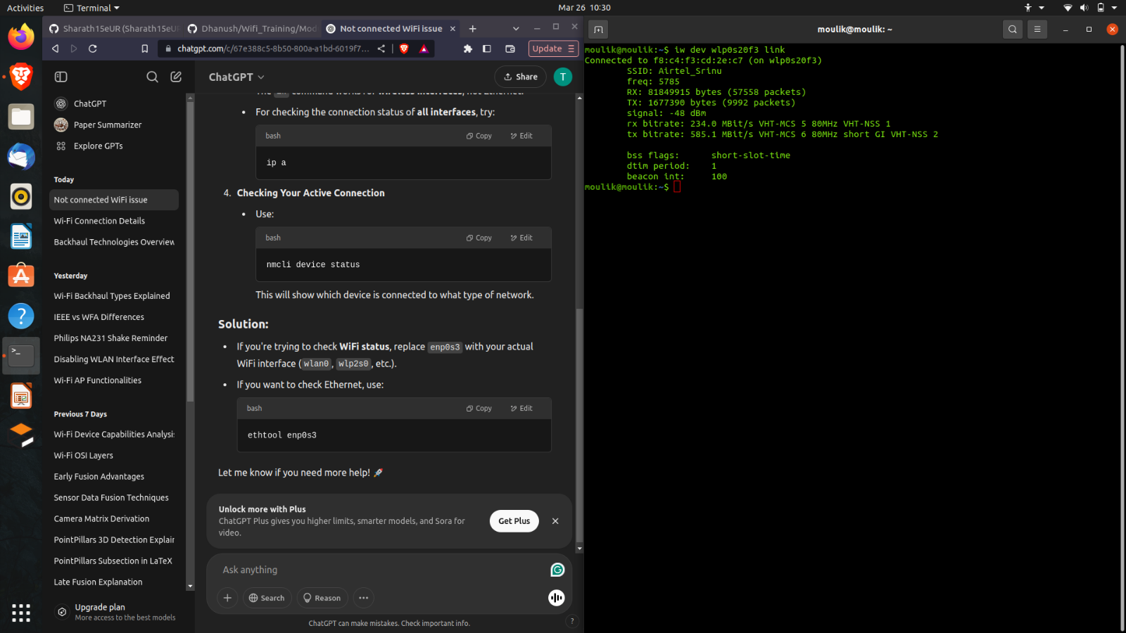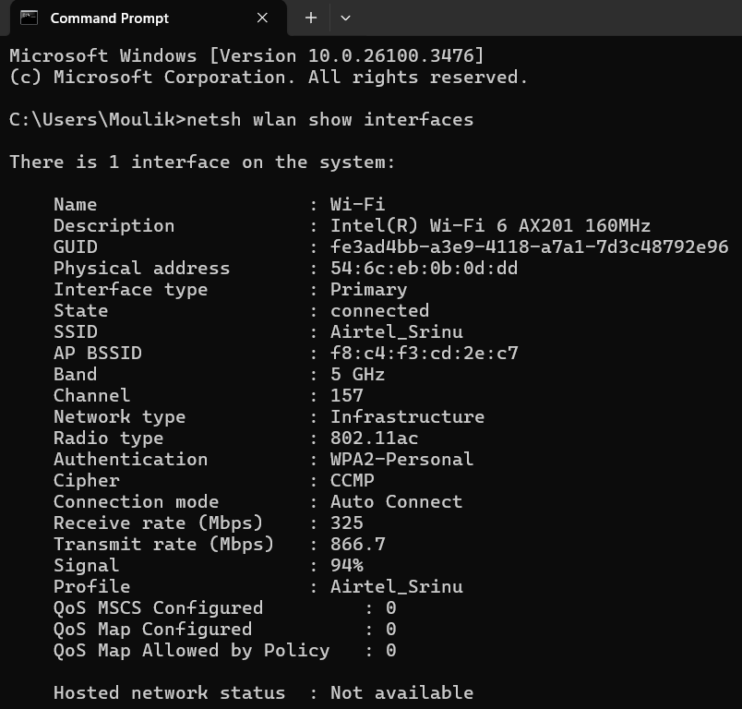

**Linux System:**

**Windows System:**

* **Interface**: Intel(R) Wi-Fi 6 AX201 160MHz
* **Frequency**: 5 GHz
* **Signal Strength**: 94%
* **Receive Rate**: 325 Mbps
* **Transmit Rate**: 866.7 Mbps
* **Radio Type**: **802.11ac** (Wi-Fi 5)
* **Interface**: wlp0s20f3
* **Frequency**: 5785 MHz (5 GHz band)
* **Signal Strength**: -48 dBm
* **Rx Bitrate**: 234.0 Mbit/s
* **Tx Bitrate**: 585.1 Mbit/s (VHT-MCS 6, VHT-NSS 2, Short GI)
* **Wi-Fi Standard**: **802.11ac (Wi-Fi 5)**

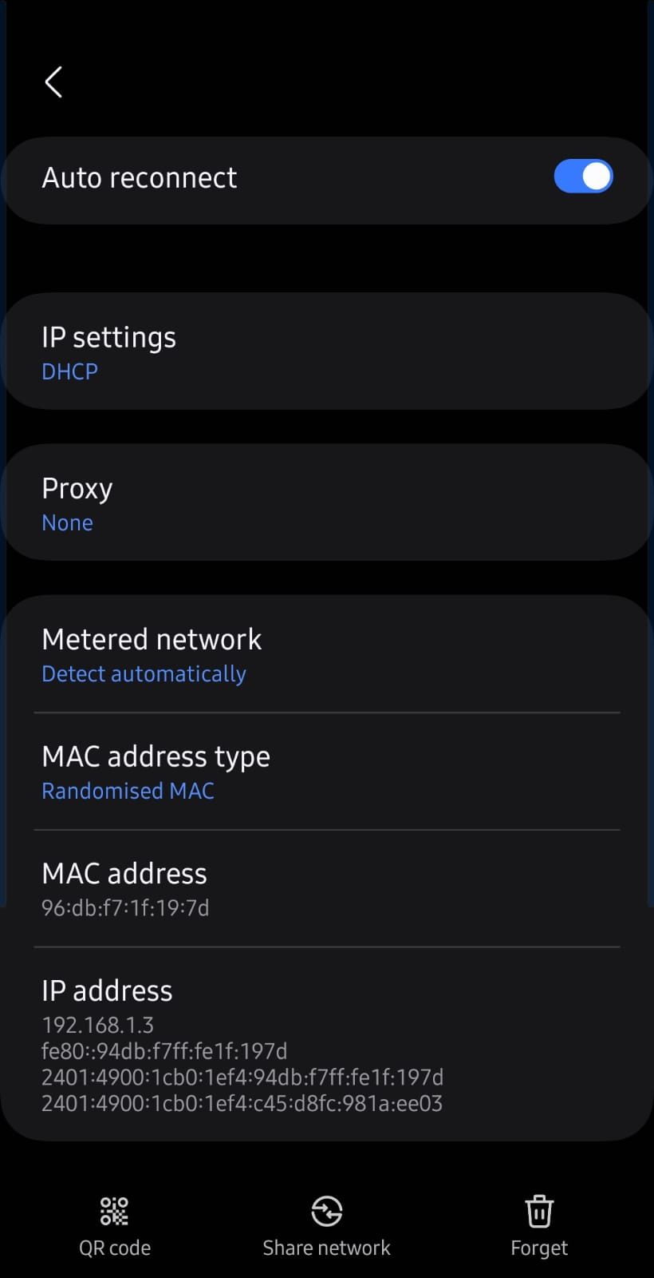

The image displays a mobile device’s Wi-Fi settings. It uses DHCP for automatic IP assignment and has no proxy configured. The network is marked as metered to limit background data. The MAC address type is set to Randomized MAC for privacy, with the MAC address 96:db:f7:1f:19:7d. The assigned IP address is 192.168.1.3, with additional IPv6 addresses present, enabling dual-stack communication over both IPv4 and IPv6 protocols.

|  |  |  |
| --- | --- | --- |
| **Wi-Fi Generation** | **IEEE Standard** | **Frequency Bands** |
| Wi-Fi 1 | 802.11b | 2.4 GHz |
| Wi-Fi 2 | 802.11a | 5 GHz |
| Wi-Fi 3 | 802.11g | 2.4 GHz |
| Wi-Fi 4 | 802.11n | 2.4 GHz / 5 GHz |
| Wi-Fi 5 | 802.11ac | 5 GHz |
| Wi-Fi 6 | 802.11ax | 2.4 GHz / 5 GHz |
| Wi-Fi 6E | 802.11ax | 2.4 GHz / 5 GHz / 6 GHz |
| Wi-Fi 7 | 802.11be | 2.4 GHz / 5 GHz / 6 GHz |

**Q3. What is BSS and ESS?  
BSS (Basic Service Set): BSS is the basic component of a Wi-Fi network, made up of a single access point (AP) and the stations (devices) that are connected to it. A distinct Basic Service Set Identifier (BSSID), usually the access point's MAC address, is used to identify each BSS. A BSS facilitates communication between linked devices and the AP while operating within a predetermined coverage area. A Basic Service Set (BSS) example is a home Wi-Fi network, where a single router (AP) connects multiple devices like phones and laptops.**

**ESS (Extended Service Set): ESS is a network consisting of multiple BSSs connected through a distribution system (such as Ethernet). This enables seamless roaming, allowing devices to move between access points while maintaining connectivity. ESS networks are commonly used in large areas like offices, universities, and shopping malls to provide broader Wi-Fi coverage. An Extended Service Set (ESS) example is a university campus Wi-Fi, where multiple routers (APs) are interconnected. Students can move across buildings while staying connected, as the network seamlessly hands off between access points.**

**Q4. What are the basic functionalities of Wi-Fi Access Point (AP).**

**Hubs, switches, routers, gateways, bridges and modems are all Wi-Fi access points. These are the function of the Wi-Fi Access Points:**

1. **Wireless Connectivity:** Provides wireless network access to devices like smartphones, laptops, and IoT devices and acts as a bridge between wired and wireless networks.
2. **Signal Transmission & Reception:** Transmits Wi-Fi signals for devices to connect within a specific coverage area and receives data from connected devices and forwards it to the wired network.
3. **Multiple Device Handling:** Manages multiple simultaneous connections efficiently using MIMO (Multiple Input Multiple Output) technology. This is done by using techniques like Beamforming to direct signals toward connected devices for better performance.
4. **Bandwidth Management & QoS (Quality of Service):** Prioritizes network traffic for critical applications like VoIP, gaming, and video streaming and also distributes available bandwidth among connected devices.
5. **IP Address Assignment & DHCP:** Can act as a DHCP server to assign IP addresses dynamically to connected devices by using the DORA process.
6. **Network Bridging & Ethernet Integration:** Connects to wired networks via Ethernet to extend wireless connectivity and also supports VLAN (Virtual Local Area Networks) for network segmentation.
7. **Mesh Networking (in Mesh APs):** Enables multiple access points to interconnect and extend coverage without requiring wired backhaul.
8. **Guest Network Support:** Creates isolated networks for guests to prevent unauthorized access to internal systems.
9. **Power over Ethernet (PoE):** Supports PoE to receive power and data over a single Ethernet cable, reducing cable clutter which is useful in enterprise environments where separate power sources are not available.
10. **Firmware Upgradability:** Can be updated remotely to fix bugs, improve security, and add new features and also supports automatic updates or manual installation by network administrators.
11. **Interference Mitigation & Channel Selection:** Which will automatically select the best frequency channels to reduce interference. It uses features like DFS (Dynamic Frequency Selection) to avoid congested frequencies.
12. **MAC Filtering & Access Control:** Which helps in restricting or allows access to specific devices based on their MAC addresses using ACL (Access Control List). This helps in improving the security of a device and controlling unauthorized device access to the network.

**Q5. Difference between Bridge mode and Repeater mode.**

|  |  |  |
| --- | --- | --- |
| **Features** | **Bridge Mode** | **Repeater Mode** |
| **Purpose of Usage** | **Connects two separate networks, allowing communication between them.** | **Extends the range of an existing Wi-Fi network without creating a new one.** |
| **Functionality** | **Acts as a link between a wired and a wireless network or between two wired networks.** | **Receives the Wi-Fi signal and rebroadcasts it to increase coverage.** |
| **IP Address Assignment** | **Devices connected to the bridge maintain their own IPs from the main router.** | **Devices connected to the repeater may get IPs from the main router or the repeater.** |
| **SSID Behaviour** | **May or may not have the same SSID on both sides.** | **Usually keeps the same SSID for seamless roaming but can have a different SSID if configured.** |
| **Use Case** | **Used to connect two physically distant buildings, networks, or LANs.** | **Used in homes, offices, and large areas to eliminate Wi-Fi dead zones.** |
| **Data Transmission** | **Transfers data between networks without altering packets (Layer 2 forwarding).** | **Receives, amplifies, and retransmits the Wi-Fi signal (Layer 1 processing).** |
| **Device Connectivity** | **Devices connect through the bridge to communicate between two separate networks.** | **Devices connect to the repeater just like a normal Wi-Fi router.** |

**Q6. what are the differences between 802.11a and 802.11b.**

|  |  |  |
| --- | --- | --- |
| **Features** | **802.11a** | **802.11b** |
| **Frequency Band** | **Uses 5 GHz** | **Uses 2.4 GHz** |
| **Interference** | **Less interference due to 5 GHz usage** | **More interference due to 2.4 GHz congestion** |
| **Maximum Speed** | **54 Mbps (faster due to higher frequency helps in carrying data more quickly but lose in range faster).** | **11 Mbps (slower dues to low frequency but travels farther but transmits less data per second).** |
| **Use Case** | **High-speed applications like video streaming and VoIP** | **Basic internet browsing and email usage** |
| **Backward Compatibility** | **Not compatible with 802.11b** | **Compatible with 802.11g** |
| **Range** | **Short range and weaker penetration through walls causing more signal loss** | **Longer range and better penetration through walls and obstacles** |

**Q7. Configure your modem/hotspot to operate only in 2.4Ghz and connect your laptop/Wi-Fi device, and capture the capability/properties in your Wi-Fi device. Repeat the same in 5Ghz and tabulate all the differences you observed during this.**

**I have changed the WLAN setting by disabling 5GHz WLAN while testing 2.4GHz WLAN and vice versa.**

**2.4GHz:**

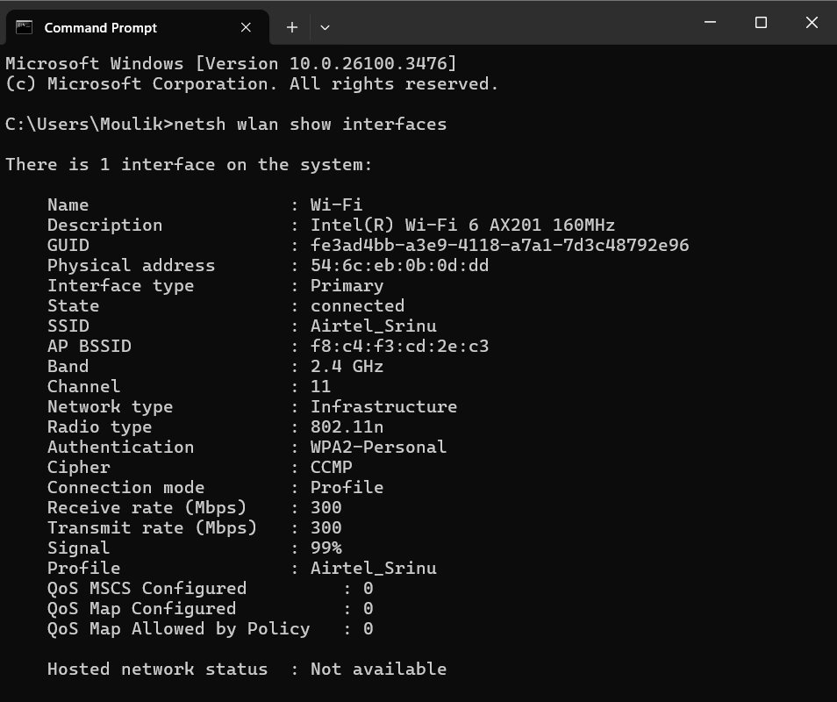

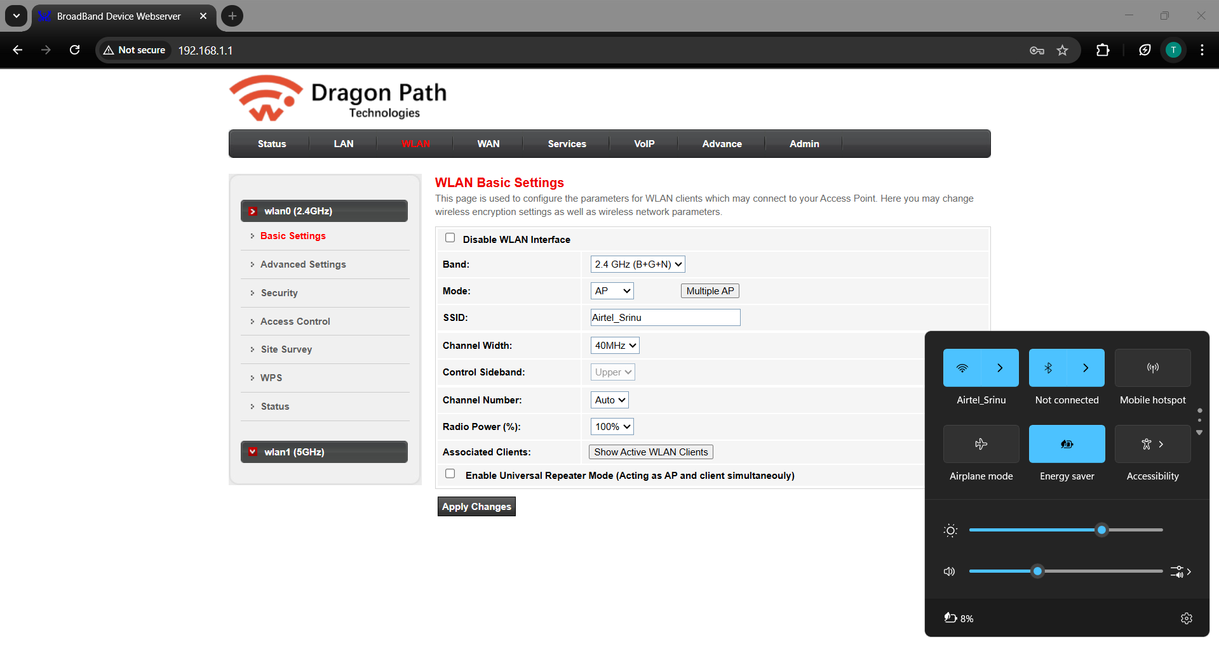

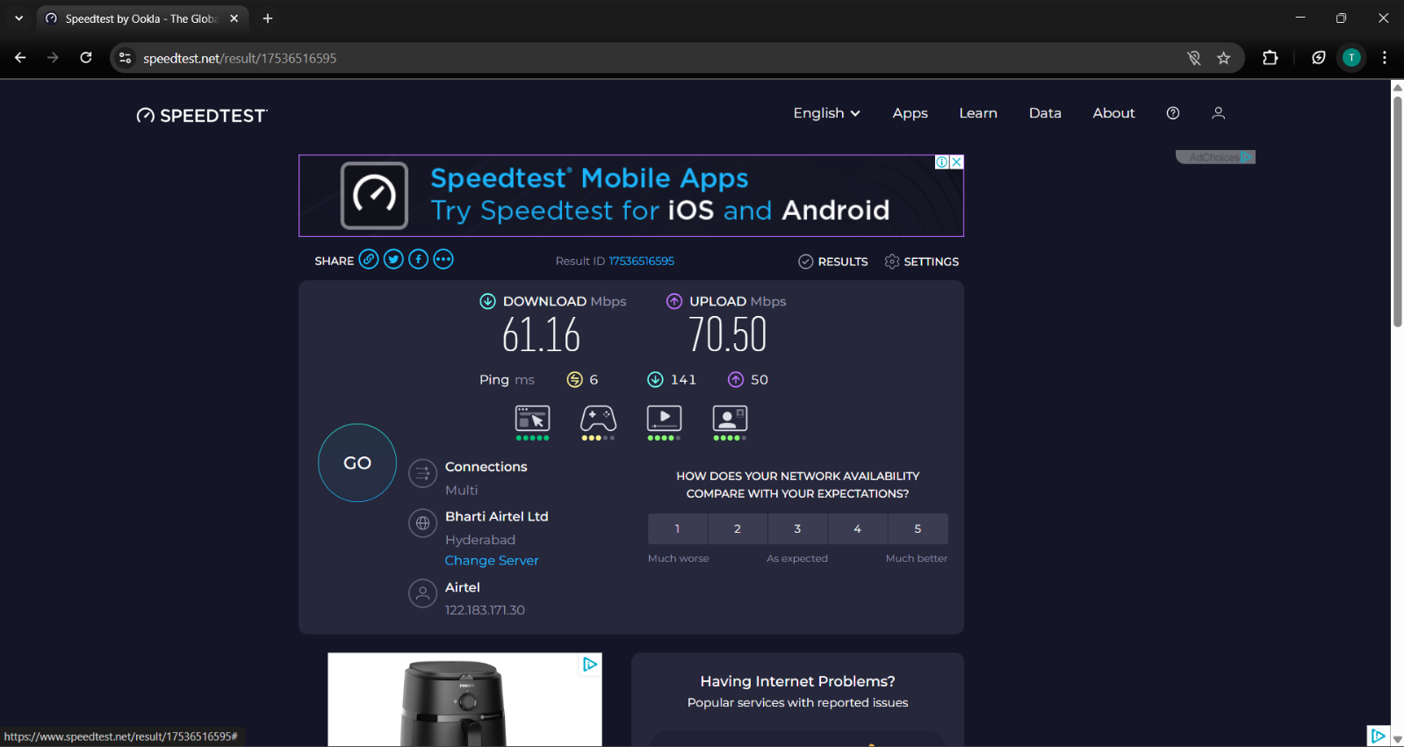

**When we connect to the 2.4GHz Wi-Fi, the speed is comparatively less compared to the 5GHz Wi-Fi.**

**5GHz:**

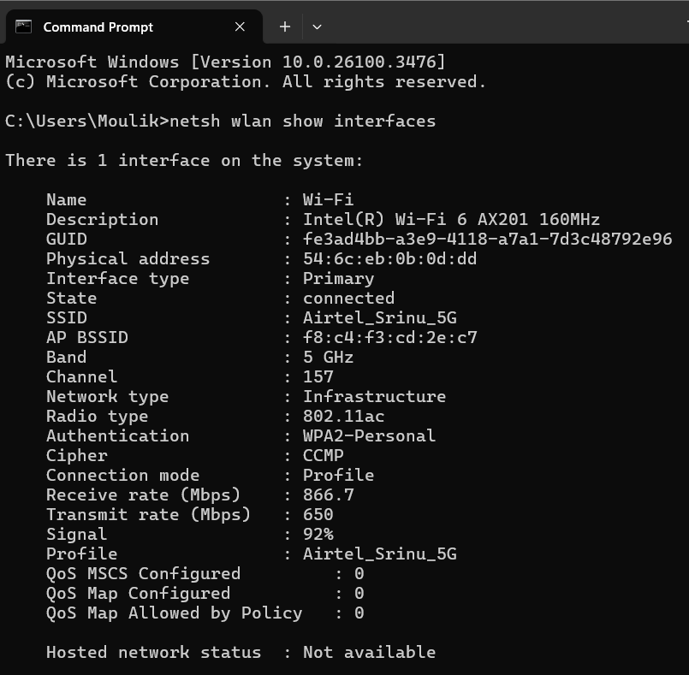

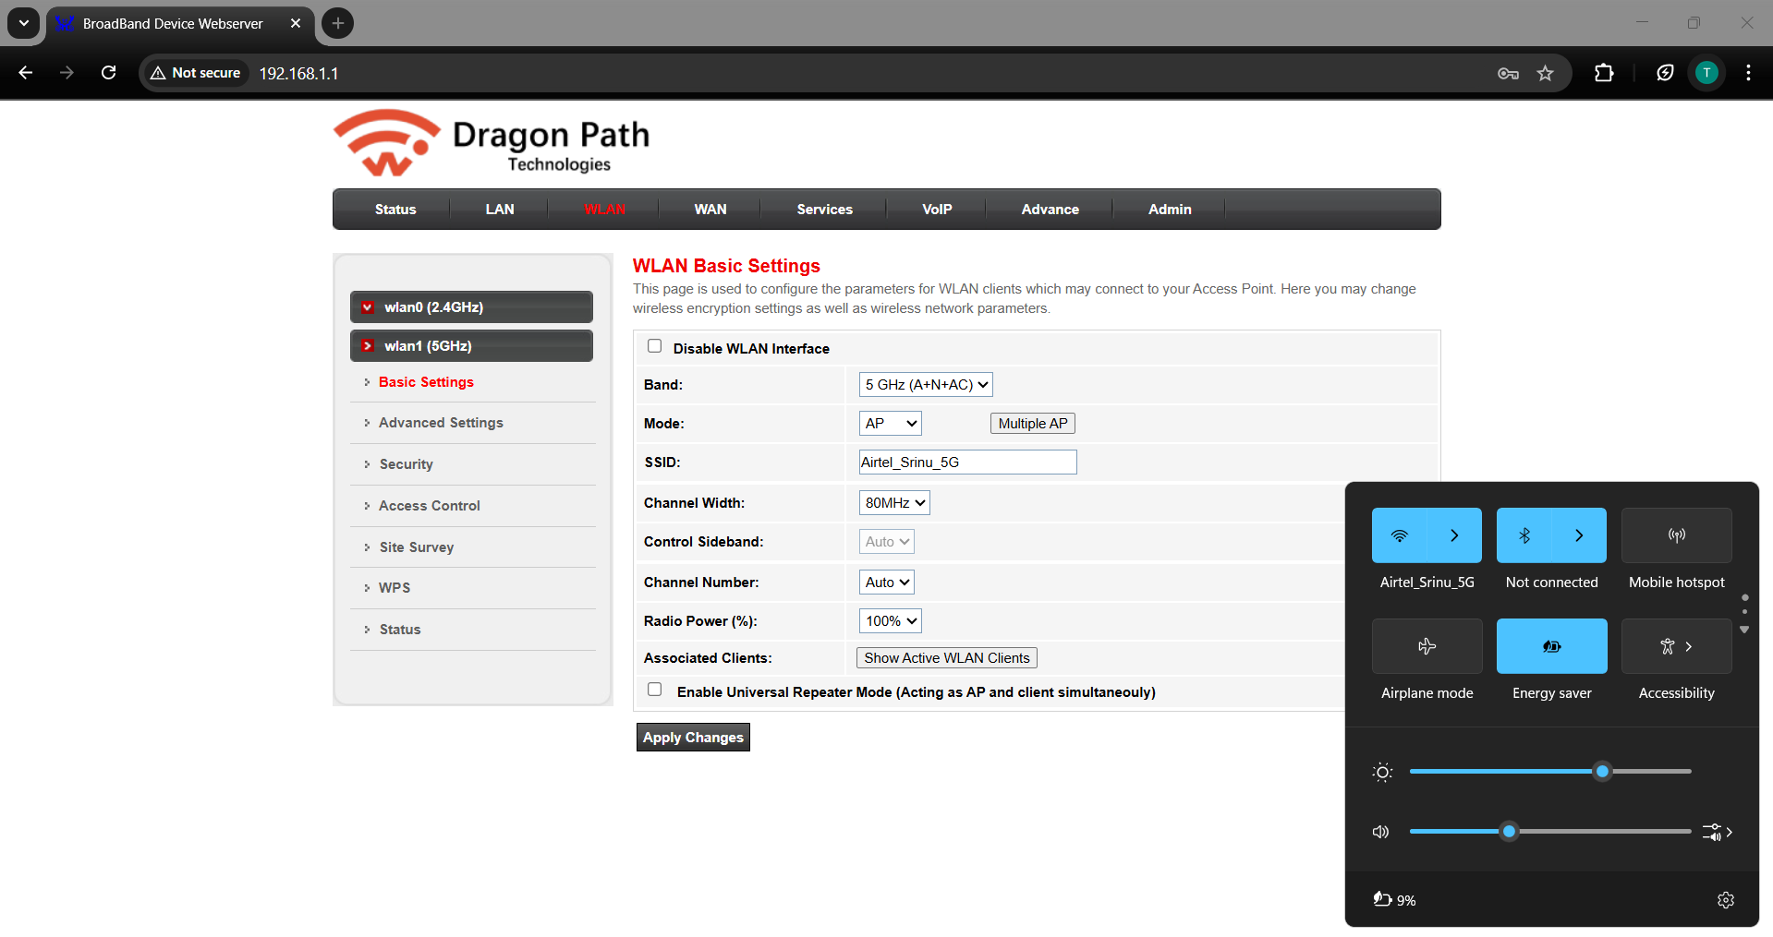

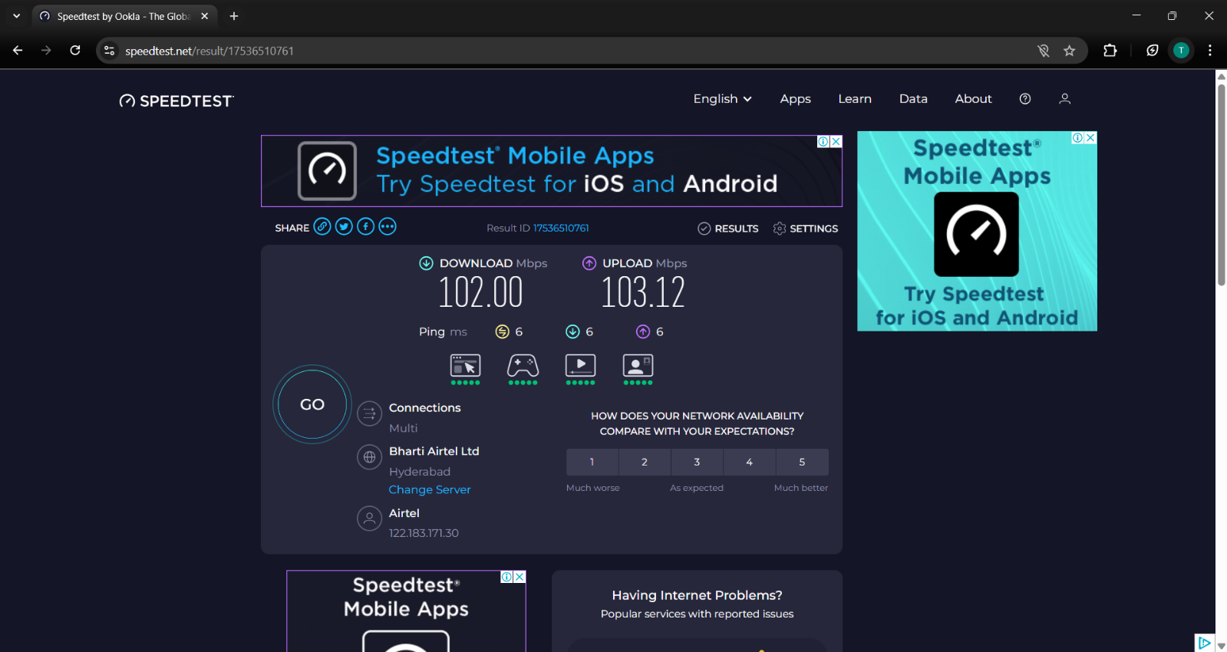

|  |  |  |
| --- | --- | --- |
| **Features** | **2.4GHz** | **5GHz** |
| **Receive Rate** | **300 Mbps** | **866.7 Mbps** |
| **Transmit Rate** | **300 Mbps** | **650 Mbps** |
| **Signal Percentage** | **99%** | **92%** |
| **Channel** | **11** | **157** |
| **Radio type** | **802.11n** | **802.11ac** |
| **Download Speed** | **61.16 Mbps** | **102 Mbps** |
| **Upload Speed** | **70.50 Mbps** | **103.12 Mbps** |

**Note: The Receive Rate (Rx) and Transmit Rate (Tx) in “netsh wlan show interfaces” refer to the maximum possible link speed between your Wi-Fi adapter and the router, not your actual internet speed.**

**Q8. What is the difference between IEEE and WFA.**

**IEEE (Institute of Electrical and Electronics Engineers):**

* **A professional organization that sets standards for a wide range of electrical, electronic, and computing technologies.**
* **Develops networking standards such as IEEE 802.11, which forms the foundation for Wi-Fi technology.**
* **Also works in areas like AI, robotics, power systems, telecommunications, and more. Different IEEE societies work on different fields like IEEE ComSoc, IEEE Signal Processing Society etc.**
* **IEEE creates and maintains the technical standards (like 802.11) that define how Wi-Fi works.**

**WFA (Wi-Fi Alliance):**

* **A trade organization that ensures Wi-Fi products from different manufacturers are interoperable and meet industry standards.**
* **Certifies Wi-Fi devices based on the IEEE 802.11 standards.**
* **Introduces enhancements like Wi-Fi 6, Wi-Fi 7 and WPA security protocols for better connectivity and security.**
* **Focuses on branding, marketing, and ensuring end-user experience with Wi-Fi technologies.**
* **WFA tests, certifies, and promotes Wi-Fi products to ensure compliance with IEEE standards.**

**Q9. List down the type of Wi-Fi internet connectivity backhaul, share your home/college's wireless internet connectivity backhaul name and its properties.**

* **Backhaul refers to the intermediate network that connects local access points (e.g., cell towers, routers) to the core network, enabling data transmission over fiber, wireless, satellite, or other communication technologies. Types of Wi-Fi Internet Connectivity Backhaul:**
* **A backhaul is the connection between a local network (such as a home or campus Wi-Fi) and the wider internet. Here are the main types:**
* **Fiber Optic Backhaul offers speeds from 1 Gbps to over 10 Gbps with very low latency (1-10 ms) and high reliability. It is used in urban areas, universities, and large enterprises, with examples like FTTH and GPON.**
* **DSL Backhaul provides 10-100 Mbps speeds with higher latency (20-50 ms) and moderate reliability, commonly used in residential areas with copper telephone lines (e.g., VDSL, ADSL).**
* **Cable Broadband Backhaul ranges from 100 Mbps to 1 Gbps with moderate latency (10-50 ms) and high reliability but shared bandwidth, used in homes and businesses (e.g., DOCSIS).**
* **Cellular (4G/5G) Backhaul reaches up to 10 Gbps, with varying latency and reliability affected by congestion, used in rural areas and mobile networks (e.g., 5G NR, LTE-A).**
* **Satellite Backhaul offers up to 1 Gbps but has high latency, used in remote areas (e.g., Starlink, HughesNet)**

**Q10. List down the Wi-Fi topologies and use cases of each one.**

|  |  |  |
| --- | --- | --- |
| **Wi-Fi Topology** | **Description** | **Use Cases** |
| **Infrastructure Mode** | **Devices connect via a central router/AP.** | **Home, office, public Wi-Fi** |
| **Repeater Mode** | **Extends Wi-Fi coverage using a repeater.** | **Eliminating dead zones** |
| **Bridge Mode** | **Connects two separate networks.** | **LAN integration** |
| **Ad-Hoc Mode** | **Devices connect directly, no router needed.** | **Temporary networks** |
| **Mesh Mode** | **Multiple nodes provide seamless coverage.** | **Large homes, enterprises** |